Dataset link : <https://www.kaggle.com/datasets/ekrembayar/fifa-21-complete-player-dataset>

Dataset description : Data has been scraped from the publicly available website [https://sofifa.com](https://sofifa.com/).

# FIFA 21 COMPLETE PLAYER DATASET

Github link :

### **Getting the data of the youngest and biggest player**

Name K. Miura

Age 53

OVA 59

POT 59

Name César Gelabert

Age 16

OVA 57

POT 82

The oldest player is K.Miura ,while the youngest player is César Gelabert

* player with the highest OVA [Overall score]

Name L. Messi

Age 33

OVA 93

POT 93

Club FC Barcelona

* player with the lowest OVA [Overall score]

Name A. Dunbar

Age 18

OVA 45

POT 56

Club Wexford Youths

* player with the highest POT [Potenital]

Name K. Mbappé

Age 21

OVA 90

POT 95

Club Paris Saint-Germain

* player with the lowest POT

Name Song Yue

Age 28

OVA 47

POT 47

Club Tianjin TEDA FC

### **who is the fastest player ?**

Name Adama Traoré

Age 24

OVA 79

POT 85

Club Wolverhampton Wanderers

Sprint Speed 96

### **who has the slowest sprint?**

Name S. Royce

Age 47

OVA 48

POT 48

Club Gillingham

Sprint Speed 13

**Getting the top 10 players penalties:**

Name Penalties

Total number of countries in FIFA21 : 165

Total Number of clubs : 868

Foot preference Distribution:

Right 12348

Left 4066

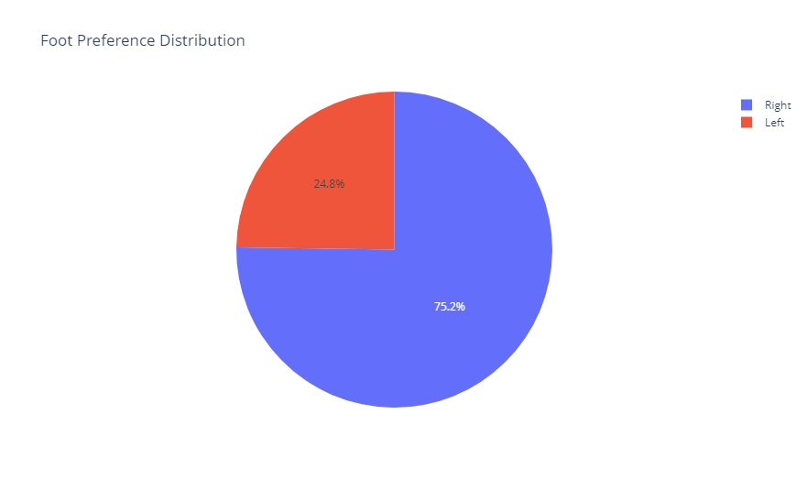

**Top 3 players left-footed:**

L.Messi → Argentina with overall score 93 at FC barcelona

M.Salah → Egypt with overall score 90 at Liverpool

T.Courtois → Belgium with overall 89 at Real Madrid

**Top 3 players Right-footed:**

Cirstiano Ronaldo → Portugal with overall score 92 at juventus

J.oblak → slovenia with overall score 91 at Atlético Madrid

R.lewandowski → Poland with overall score 91 at FC Bayern Munchen

Top 5 countries :

| England 1646  Germany 1123  Spain 1081  France 947  Brazil 763 |
| --- |

### **Top 10 Goalkeepers in FIFA 21**



              
              
              
              
              
              
              
              
              
              
              
              

 